**Some people prefer to take a gap year between high school and university, to work or to travel. Do the advantages of this outweigh the disadvantage?**

It has been suggesting that it is beneficial to have break time between school and university. Although students will understand other aspect of life during this pause and it is a broad opportunity to guide them to be ~~a~~ mature individual and see other perspective. The main disadvantage of break time is to get distract and bewildered students among plenty of option that are fake and useless and cessation their education. If apprentice has short breaks, it will give them capacity to be on track.

First, the main advantage of break time is to keeps students sharp and mighty this is due to the fact that~~,~~ it is like a recovery time. additionally, it will gives them time to think about their future. For instance, imagine a fighter that needs ~~a~~ time to get back on track and refresh the power of first step after a fight. On top of that, students get aware of other ability and talents that is as significant as education.

Second, the main disadvantage of education gap is to hold students back from the task that they have done. Hence, a vast majority of people prefer to concentrate on schooling and no halt is necessary. Besides, the nature of human is joyful and this is the week point of human that is the basic reason for consideration of this gap as a massive obstacle among all positive attempts. Furthermore, if the sequence of science exploring had stopped, it has needed more power to revive.

To recapitulate, different walks of society have believed that gap time before university education is eager to please. However, the advantage is outweigh the disadvantage, of course it is depends on people morality. As far as I concerned it is good to rest to enhance the abilities.

Dear Navid,

The key to success in Writing skill is practicing with feedback. I am so happy to hear from you again. Your score is 5.5 to 6. The most important issue that needs to fix is your mind-map. Pay attention that every sentence and word have to be related to each other!

Here are some suggestions:

1. Read below book. Believe it or not, many advance writers have basic mistakes. It is one of the greatest books that can improve your grammar.

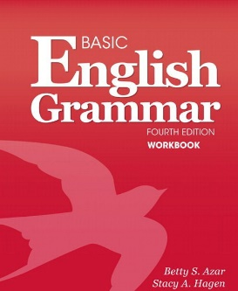

1. Read more examples with Although. The one you used in your introduction is wrong. You just named one aspect of your idea. For instance: Although being a parent is *stressful and exhausting, it is very rewarding*.
2. Your introduction is very long.
3. In body 2, you had 3 ideas (in green). However, you elaborate only one of them with an example! This will lower your CC in writing.
4. You can use first, second, third, … when you are writing one aspect.

You have to shift you view for Body 2.

For example:

|  |  |
| --- | --- |
| Introduction | - |
| Body 1 | Advantages: First, Second, Third, … (On the one hand,) |
| Body 2 | Disadvantages: Nevertheless (On the other hand,) |
| conclusion | - |